Print Element

Author: $Author

Publisher: $Publisher

Date: $date

This sample template will list all classes from selected package. The content of each class consists of class name, visibility, and its operations.

This sample gives a practical demonstration of the Velocity Template Language (VTL) usage of variable properties.

Code learning:

Print element
\$Class
\$cls.name

Looping
\#foreach (\$cls in \$Class)
\$cls.name
\#end

List of Class

#foreach ($cls in $Class)

$cls.name

Visibility
$cls.visibility

#if ($cls.hasOwnedOperation())

Operations
#foreach ($ope in $cls.ownedOperation)
- $ope.name
#end
#end

#end

More Information
You can find additional printable attributes of each element within the “Specification Dialog”

For example:

You have a class diagram with class name Customer
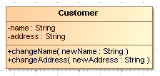
Figure 1: A Class Diagram

If you want to print attribute of Customer in a report, right click and open specification dialog of this class.

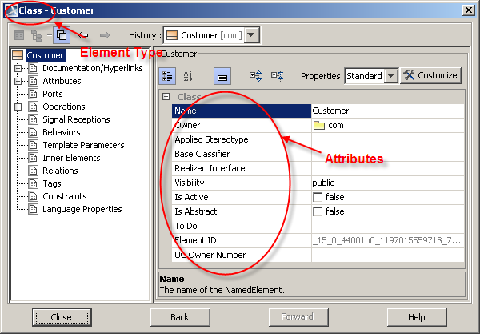
Figure 2: Display specification dialog of Customer

The element type displays on dialog title and attribute name displays on the right-hand side.

You can print other attributes of Class element by using the following statement.

#foreach ($class in $Class)
Name: $class.name
Owner: $class.owner.name
Visibility: $class.visibility
Is Abstract: $class.isAbstract

#end

The output will be
Name: Customer
Owner: com
Visibility: public
Is Abstract: false

Learn additional technical function of MagicDraw, the OMG meta-model, and get technical Java documentation from <MagicDraw install directory>\openapi\docs\

The printable element such as “Class”, “Interface”, “Use Case”, “Actor”, and “Extension Point” are contained in package “com.nomagic.uml2.ext.magicdraw” and sub-packages.

